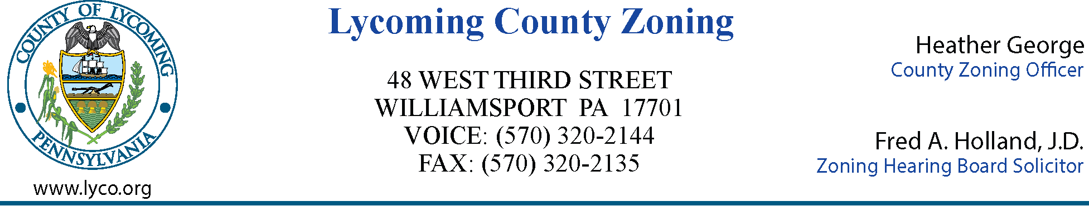

MEETING AGENDA
LYCOMING COUNTY ZONING HEARING BOARD
Third Street Plaza – 3rd Floor Commissioners Board Room
Wednesday, February 25, 2025
6:00 p.m.

- CALL MEETING TO ORDER

- ROLL CALL

- MINUTES OF PREVIOUS MEETING – November 19, 2025

- NEW BUSINESS

A. ZHB Case 2026-001
Matthew Wurster
Plunketts Creek Township
Variance

- ADJOURNMENT

